A Demonstration Plan of Model Predictive Control in

UC Merced Campus

Zhe Wang, David Blum, Donghun Kim, Tianzhen Hong, Michael Wetter, Mary Ann Piette

Building Technology and Urban Systems Division

Lawrence Berkeley National Laboratory

**March 28, 2019**

# SUMMARY

This document describes a plan to field test the campus-level MPC at the UC Merced campus. The information was collected from a site visit, meeting with the UC Merced facility manager and engineer, documents and data provided by UC Merced, as well as public information available on the web. The plan includes a description of the campus, buildings and their systems, data points, and demonstration goals and technical approaches. The demonstration schedule is estimated. This will be a living document with updates from gathering more information, as well as further discussion and collaboration with UC Merced. The project effort is funded by the U.S. Department of Energy under the joint U.S.-China Clean Energy Research Center for Building Energy Efficiency.

**Table of Content**

**I. CAMPUS DESCRIPTION** **1**

General 1

Typical buildings 3

Chiller plant 6

Thermal Energy Storage (TES) Tank 10

Condensing Water System and Cooling Tower 11

**II. DEMONSTRATION PLAN** **13**

Demonstration Goals 13

Objective functions 13

Approach 14

Risks and outstanding issues 14

**III. Demonstration Schedule** **15**

Gantt Chart 15

# 

# I. CAMPUS DESCRIPTION

## 

## **General**

The University of California, Merced, is the tenth and newest of the University of California campuses, which has three schools offering 23 undergraduate majors and 25 minors. The UC Merced campus is located in the San Joaquin Valley in Merced County, California.

## 

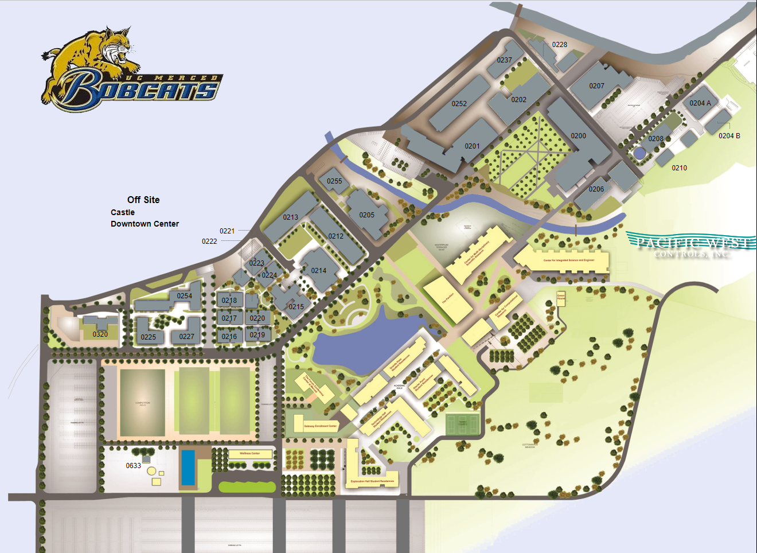

Figure 1: UC Merced Campus

UC Merced has a centralized campus/district heating/cooling system. The cooling plant is equipped with five electricity-driven chillers, while the heating plant has three oil boilers. The cooling plant also has a thermal storage tank with a design capacity of 30,000 ton-hrs (360 million BTU, or 106 MWh) to shift the day-time cooling load to night time charging. Table 1 lists the main buildings served by the centralized plant.

Table 1: A list of main buildings served by the central plant

|  |  |  |  |  |
| --- | --- | --- | --- | --- |
| Building name | Number of AHU | Number of floors | Monthly energy consumption MWh | Peak kW |
| Science & Engineering Building | 10  (3, 7, 9, 10)  10kW (30-40 kW peak from fans) | 4 | 200-400 | ~600 kW |
| Kolligian Library | 5  10kW (40-60 kW peak from fans) | 4 | 98-170 | 375 kW |
| Classroom and office Building |  | 3 | 47-75 |  |
| Facility Building | 4 | 1 | 2.9-6.5 |  |
| Gallo Rec & Wellness | 3 | 1 | 15-50 |  |
| Social Science Management Building |  | 3 | 45-65 |  |
| Dining Hall | 6 | 1 | 30-80 |  |

## **Typical buildings in the campus**

In this section, we present the cooling/heating load, supply and return chilled and hot water temperature of three campus buildings: Science & Engineering Building, Kolligian Library and the Dining Hall, representing three key campus building types. From Figure 2 - Figure 4, it could be observed that there is cooling and heating load throughout the whole year, with the peak load of heating and cooling occurring at the same time in summer.

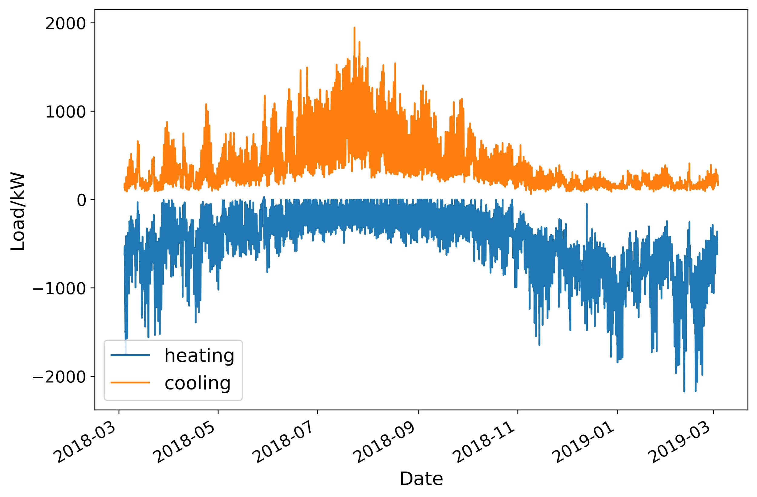

Figure 2: Cooling/heating load of the Science & Engineering Building

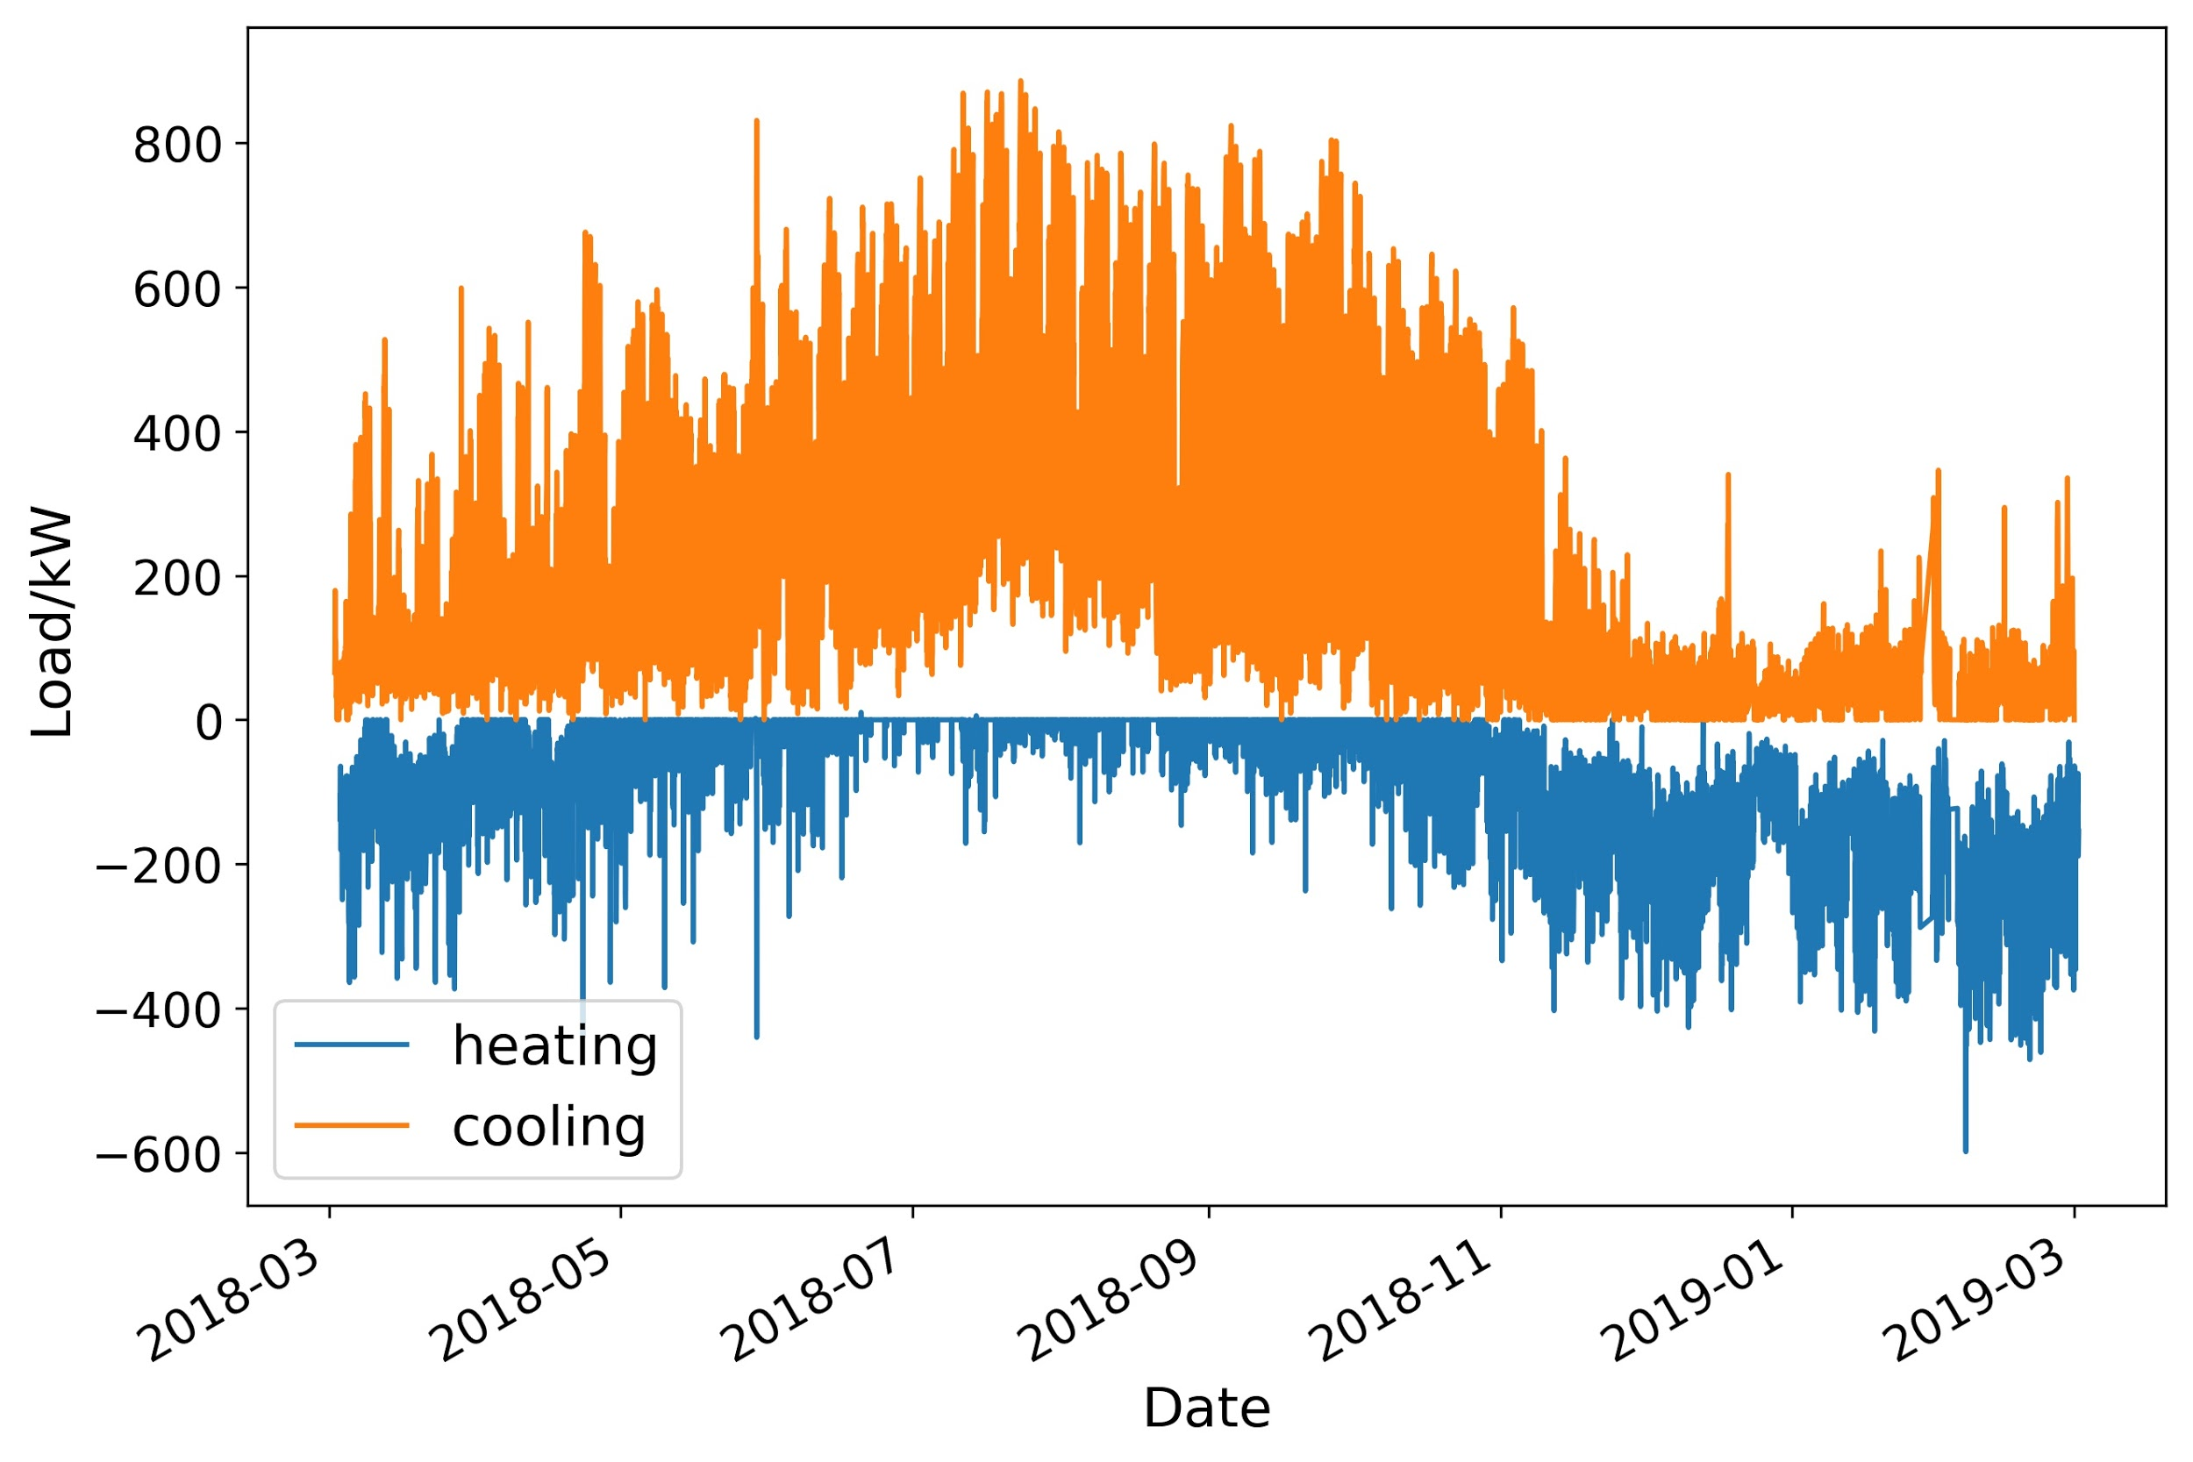

Figure 3: Cooling/heating load of the Kolligian Library

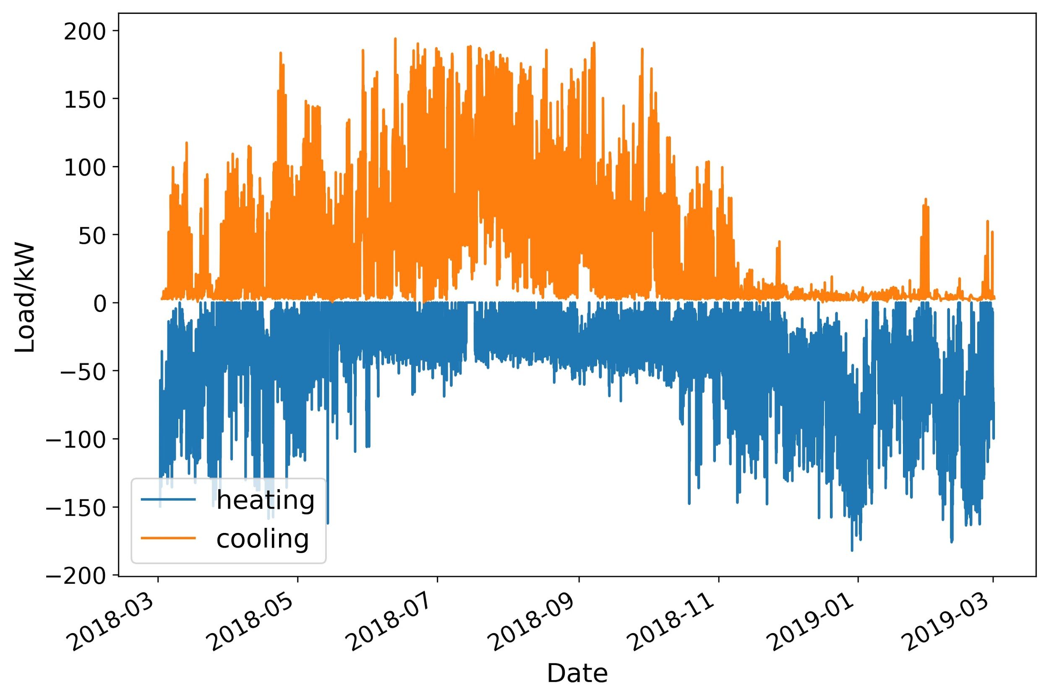

Figure 4: Cooling/heating load of the Dining Hall

Figure 5 shows the supply and return water temperature of the three buildings. The supply chilled water temperature is in the range of 38-42 degF for all three buildings. However, the return chilled water temperature varied a lot: for the Science & Engineering building it is the lowest, between 50 and 60 degF, while for the Kolligian Library it is around 70 degF. As for the heating system, the supply and return hot water temperature varied in a wide range.

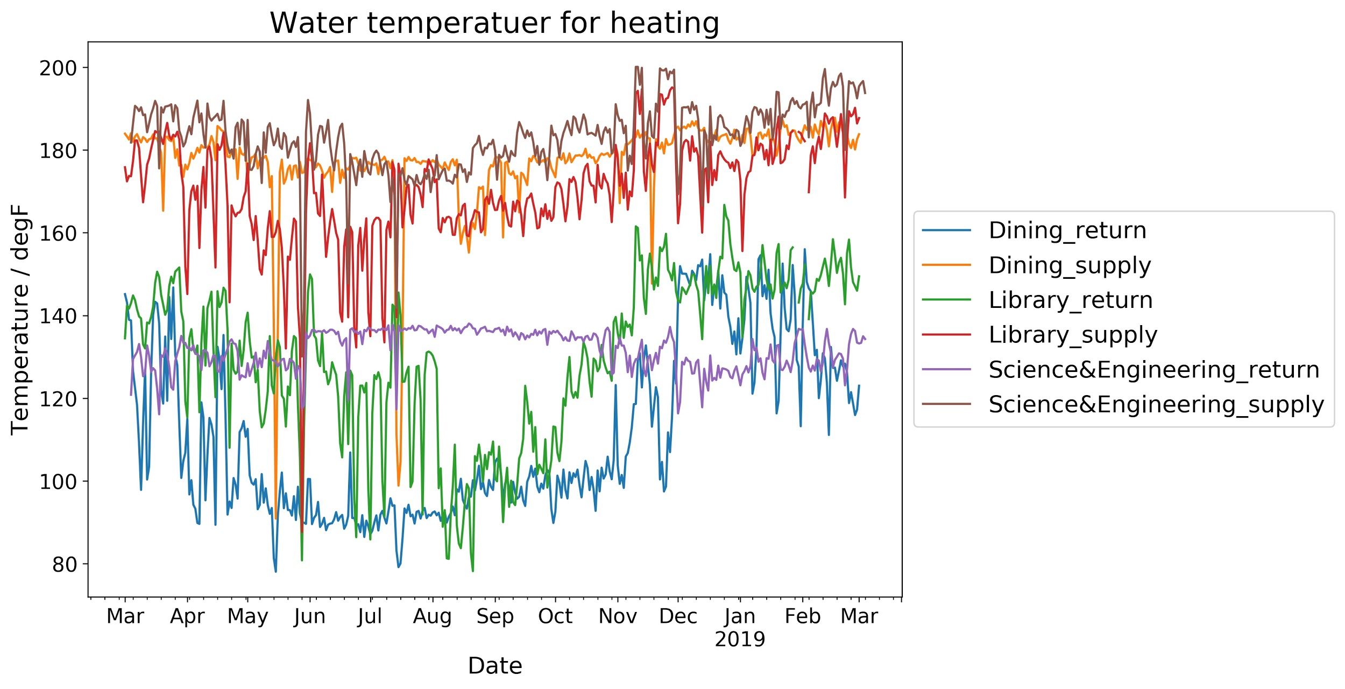

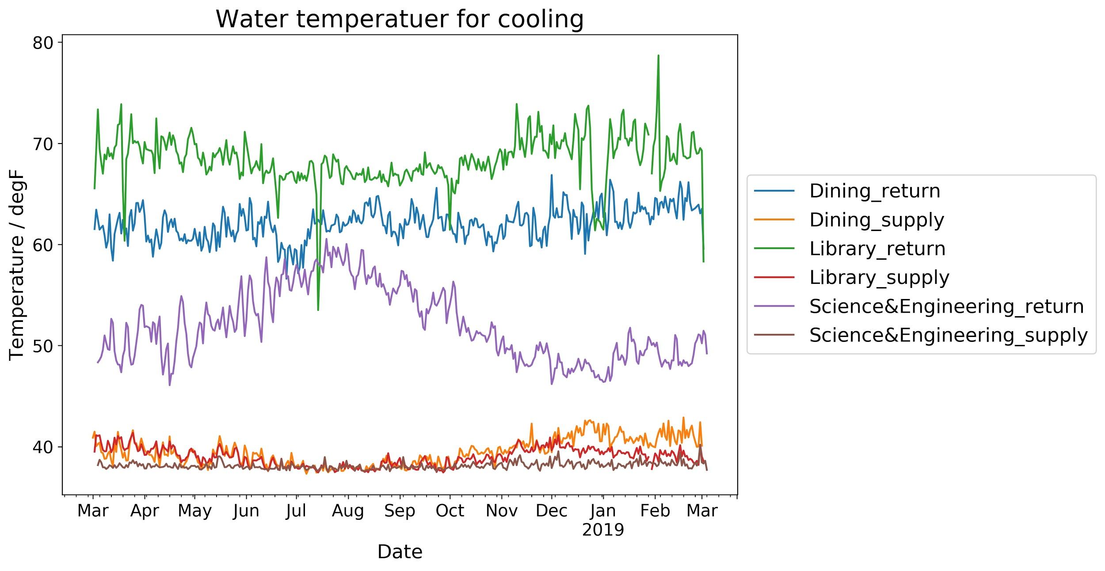

Figure 5: Daily average supply and return water temperature of the three typical campus buildings

## **Chiller plant**

In the cooling plant, there are five electric chillers by Carrier and a thermal energy storage tank with 30,000 ton-hrs of design capacity.

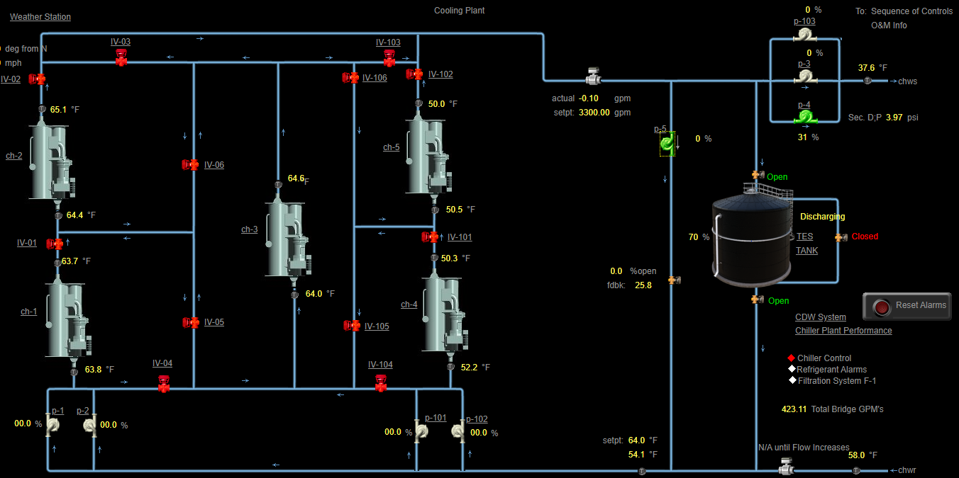

Figure 6: Screen capture of the cooling plant of UC Merced

Figure 7 and Figure 8 show the performance of Chiller 4 and Chiller 5. It could be observed that, Chiller 4 and Chiller 5 are in series connection: Chiller 4 cools the return chilled water from around 13 degC to 7.5 degC, and Chiller 5 further cools the water from 7 degC to 2.5 degC. As for the condenser water, Chiller 4 and Chiller 5 share the same cooling towers and have the similar condenser water supply temperature. During this week, the mean supply condenser water temperature is 19 degC, and the mean return condenser water temperature is 24 degC.

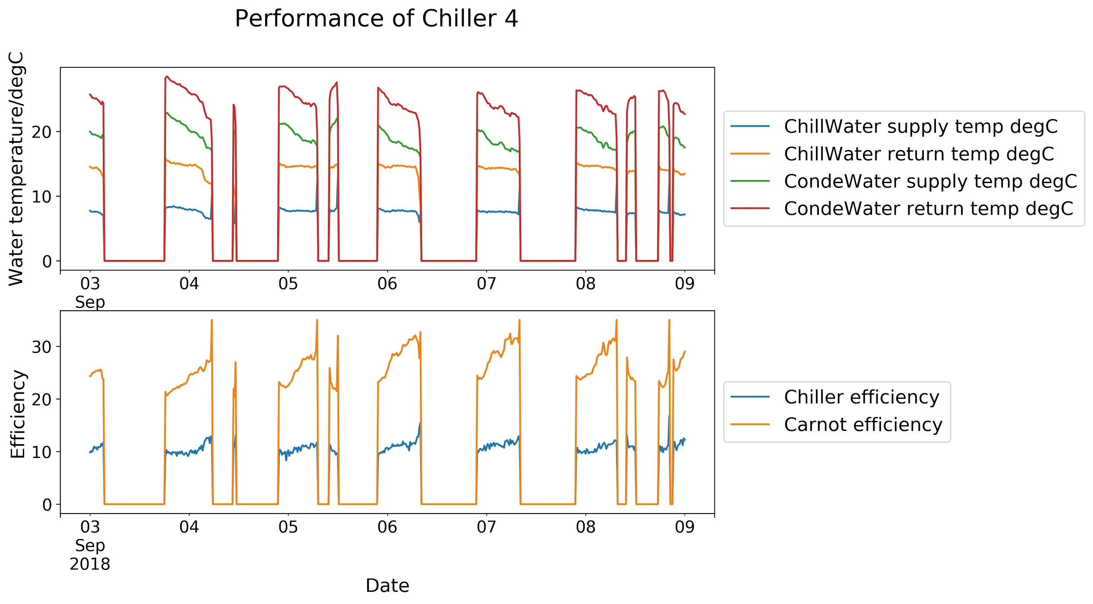

Figure 7: The performance of Chiller 4 in a typical summer week

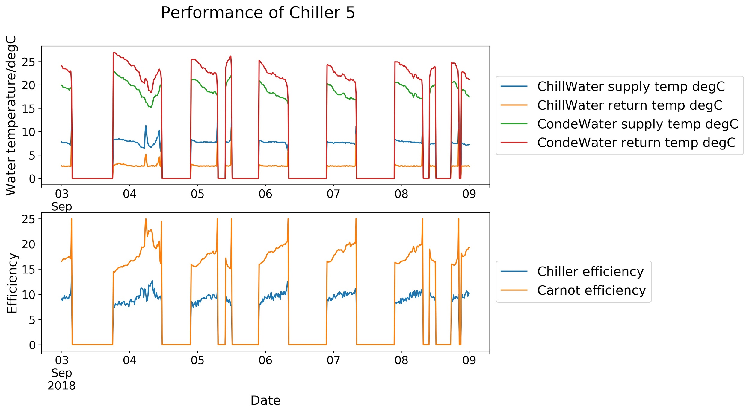

Figure 8: The performance of Chiller 5 in a typical summer week

The theoretical Carnot efficiency COP is calculated in Equation 1 (T in degK), where we use the average inlet and outlet water temperatures as the approximation of the chilled and condenser water temperature in the calculation.

$COP(Carnot)=T_{condenser}/(T_{condenser}-T_{chilled})$ Equation 1

As the chilled water temperature of Chiller 4 is higher than Chiller 5 and the condenser water temperatures are similar, the Carnot efficiency of Chiller 4 should be higher. In practice, the Carnot efficiency of Chiller 4 is 30% higher than that of Chiller 5 (24 vs. 18). However, the operational efficiency of Chiller 4 is only 10% higher than that of Chiller 5 (10 vs. 9). Therefore, the low chilled water temperature does not deteriorate the chiller efficiency as much as the Carnot efficiency suggest, which might be because the compression ratio under 5degC/22degC of Chiller 5 is closer to the rated compression ratio of the chillers than the compression ratio under 10degC/22degC of Chiller 4.

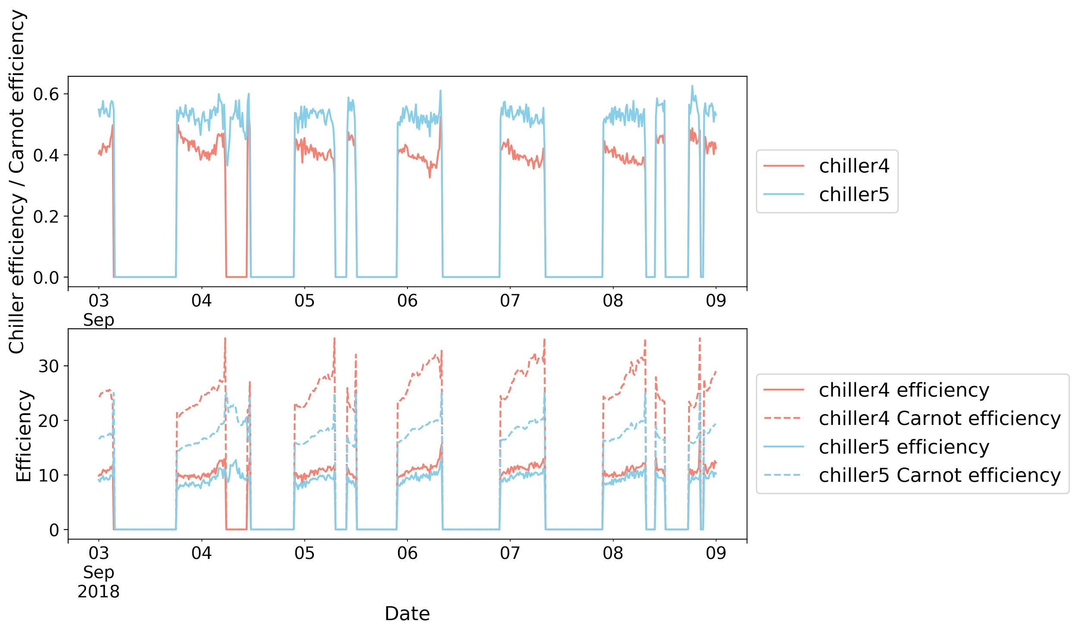

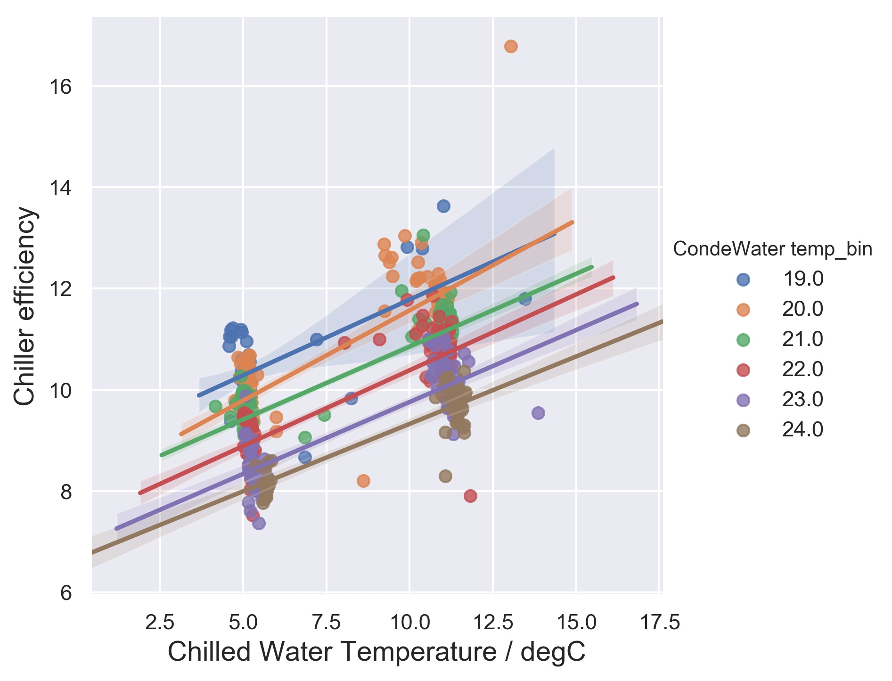

Figure 9: Chiller efficiency comparison of Chiller 4 and Chiller 5

## **Thermal Energy Storage (TES) Tank**

## 

Figure 10 plots the daily maximum and minimum percent capacity of TES tank in the past year. On some extreme warm days in June and September, the percent capacity of TES tank reached around 10%. According to the control sequence of TES Tank provided by the manufacturer, when the thermal energy store reaches 10% capacity, a Level 3 alarm shall be raised indicating ‘ONLY 10% THERMAL STORAGE REMAINING’. (This advisory will permit the operator to allow the plant to continue to operate automatically, or to manually start the chiller plant via the operator’s workstation.). The 10% alarm has seldom been triggered.

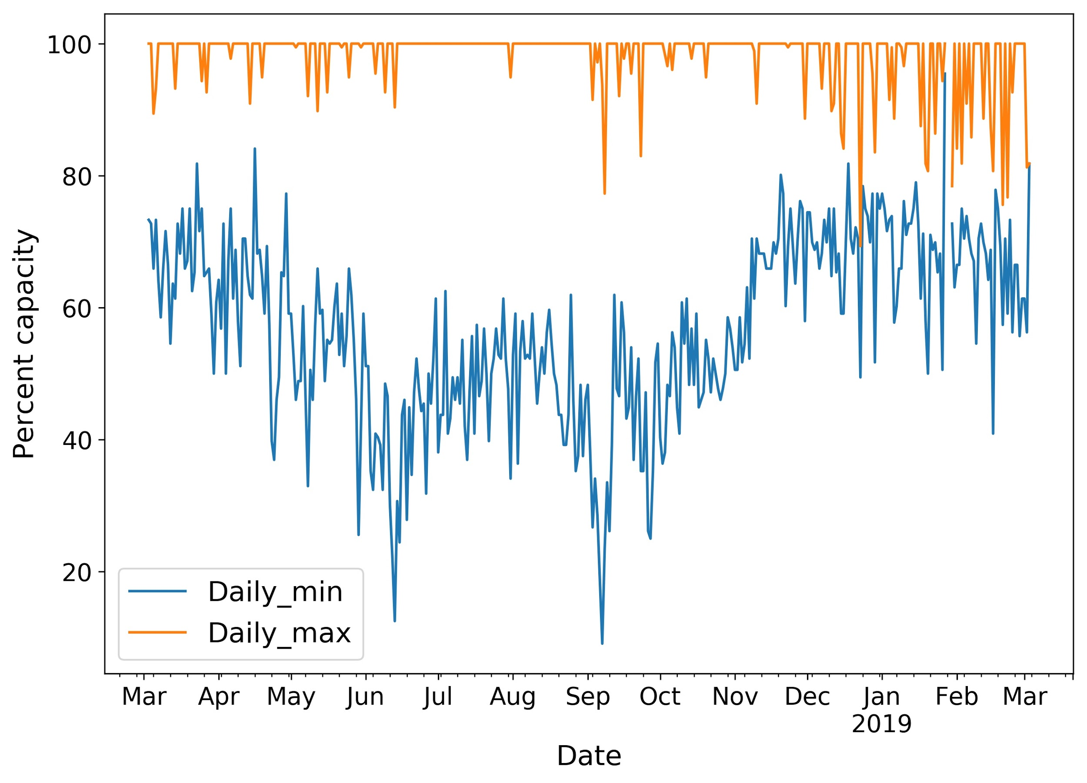

Figure 10: Daily range of percent available capacity of the Thermal Energy Storage Tank

We selected a warm week in September when the thermal energy storage was maximally used last year, i.e., in the week of 03 - 09 Sep, and then analyzed the TES charging and discharging operation of this specific week and two consecutive days, as shown in Figure 12. Figure 12 also shows the time-of-use tariff for electric energy. It could be seen that the cooling demand is high between 10AM and 12AM. The chiller works only at night between 8PM and 6AM, i.e. the chillers (as well as the cooling towers) mainly ran during the off-peak hours (between 9:30 pm to 8:30 am) and partial-peak hours (between 6:00 pm to 9:30 pm).

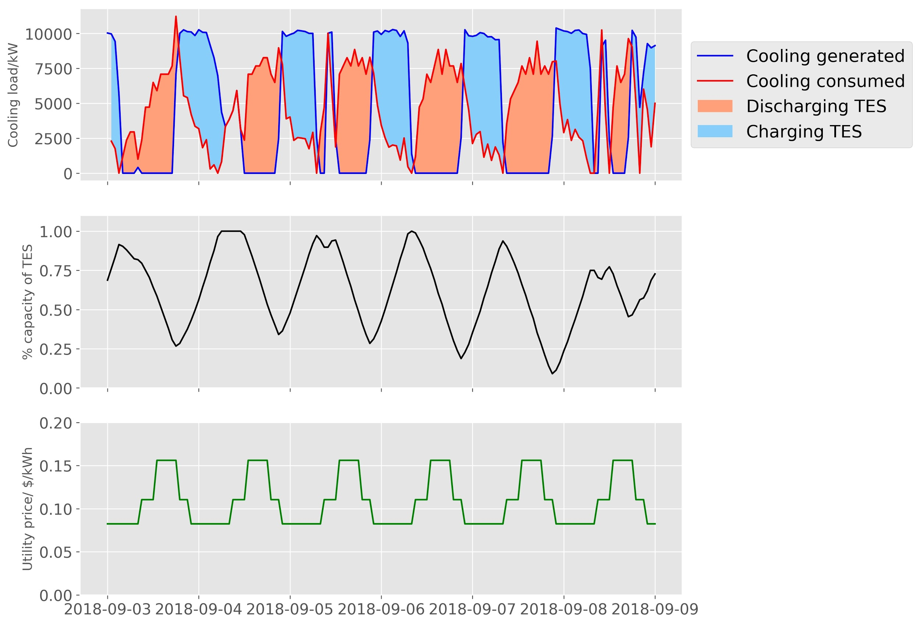

Figure 11: Operation of TES for a typical summer week

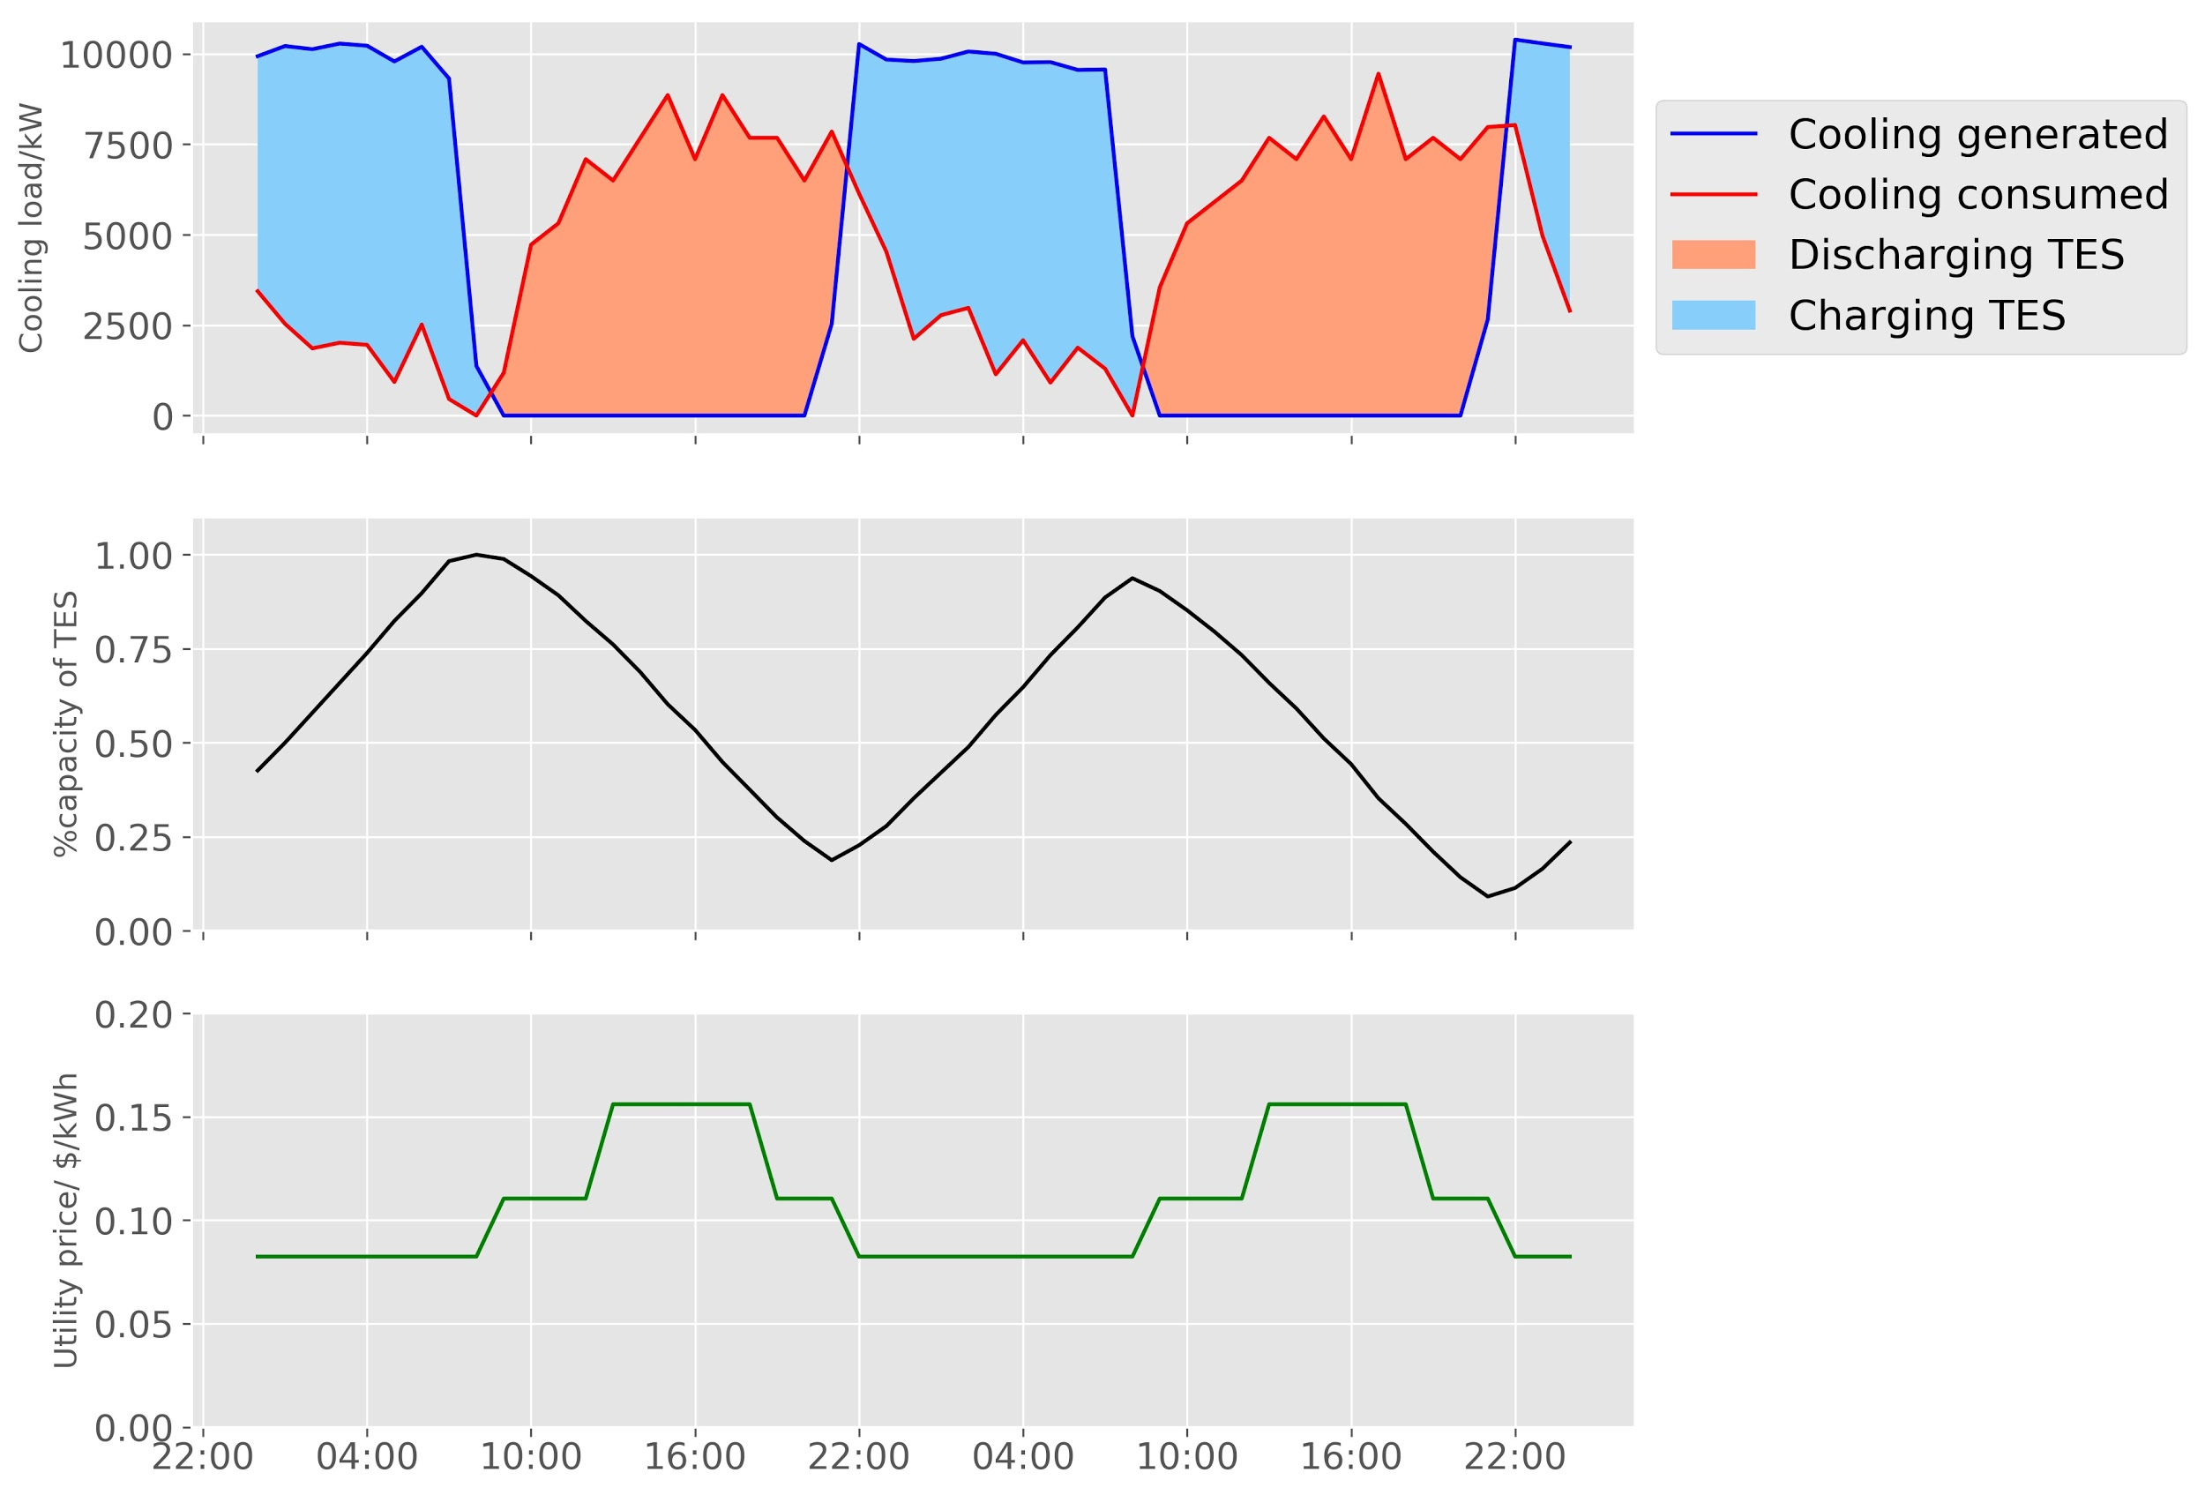

Figure 12: Operation of TES for two typical summer days

## **Condensing Water System and Cooling Tower**

Figure 13 plots the condensing water system, which has nine cooling towers (CT). The nine cooling towers are connected in parallel. As illustrated in Figure 14, the cooling towers were operated at the same pace, which were turned on and off at the same time. It could also be observed that CT1 to CT5 have similar fan motors, with rated power of around 20kW; CT6 and CT7 share similar fans of rated power of 40kW; CT8 and CT9 have the most powerful fans, with a rated power of 50kW.

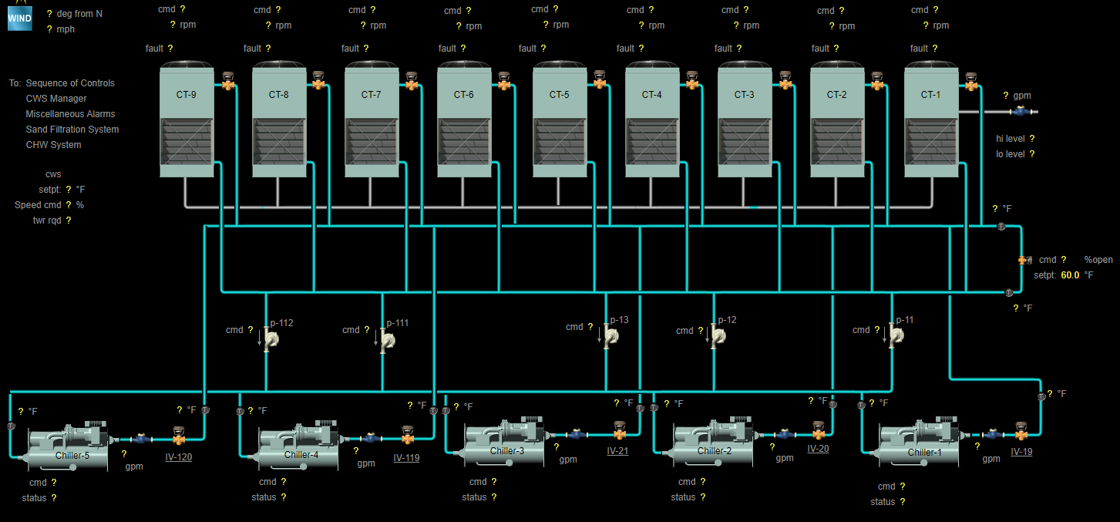

1. System diagram

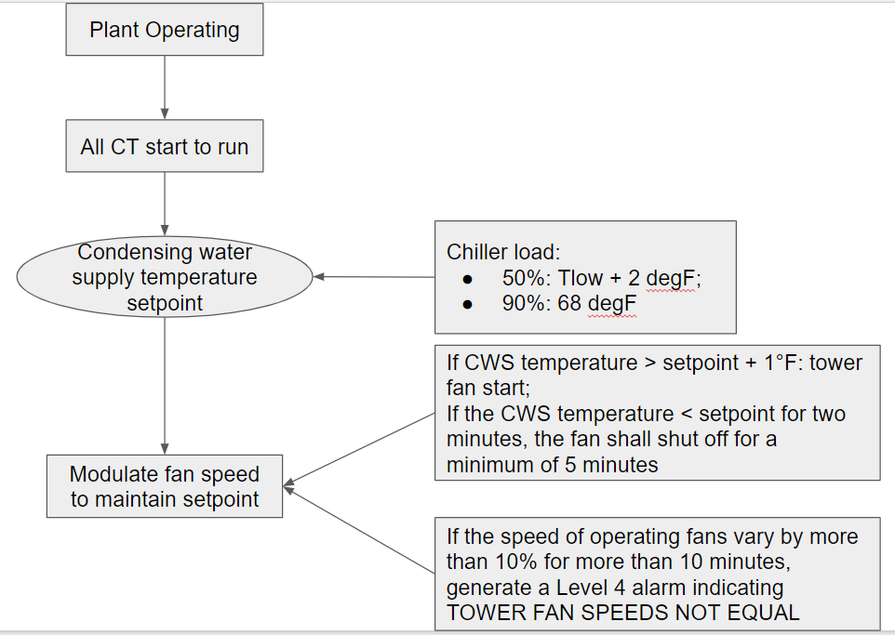

1. Control logic

Figure 13: Condensing water system

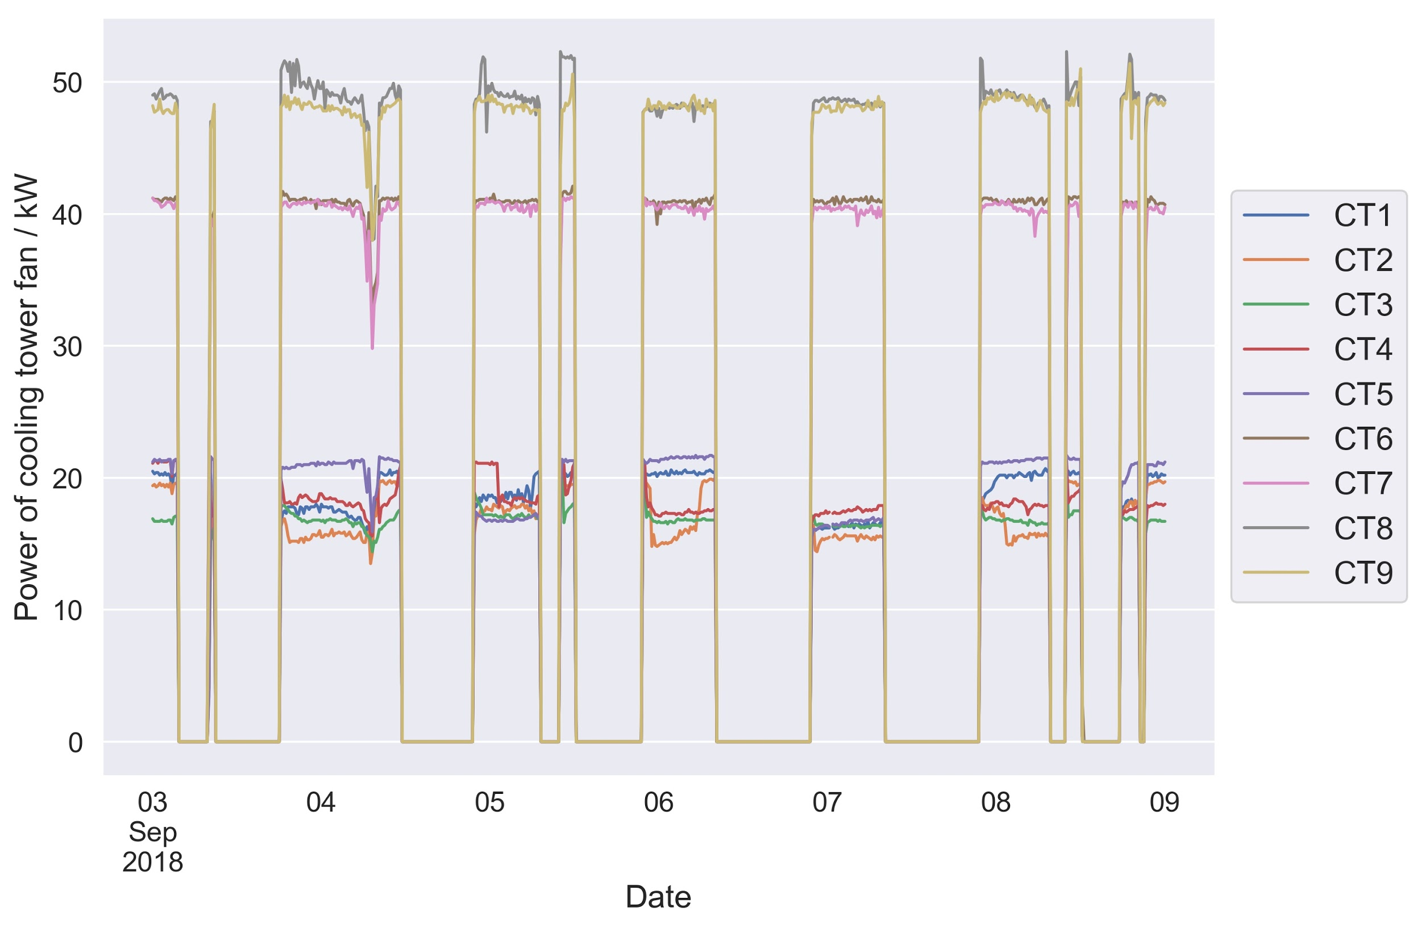

1. Power consumption

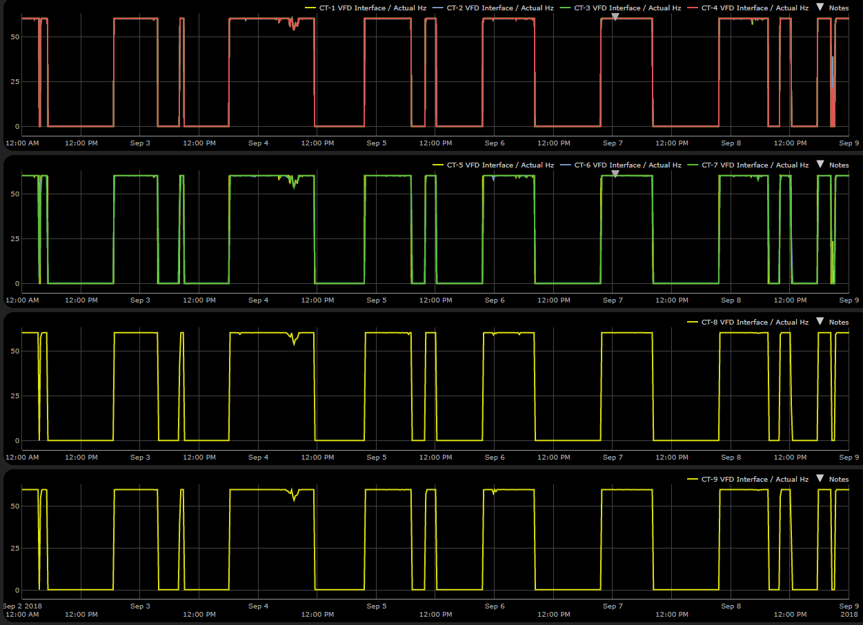

1. VFD frequency

Figure 14: Power consumption of the fans of each cooling tower

Figure 15 plots the condensing water temperature of each cooling tower. The cooling tower cooled the condensing water from around 24 degC to 19 degC.

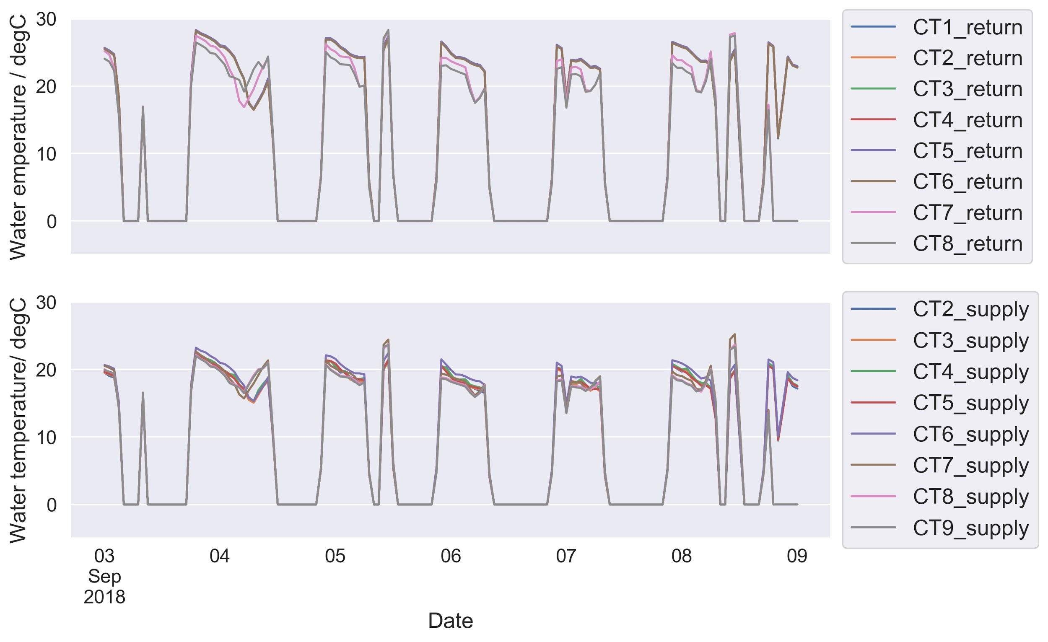

Figure 15: Condensing water temperature of each cooling tower

# II. DEMONSTRATION PLAN

## 

## **Demonstration Goals**

The demonstration goal is to field test a hierarchical occupancy-responsive model predictive control (MPC) at a campus level, aiming to optimize the operation of the central cooling plant (chiller plant, cooling tower, distribution system and etc.), Thermal Energy Storage (TES), and building HVAC based on utility price, utility DR signal, solar PV generation and load prediction to reduce energy use, utility bills, and GHG emissions. In order to provide maximum benefit to the demonstration site, our focus will be on the minimization of utility bills. With time-of-use pricing and demand response programs, we believe lowering the utility bill will also have the macro grid benefits of reducing energy use and GHG emissions. Our test case will be the campus level system (HVAC and TES) interaction with the building level system.

## **Objective: Utility Bill Minimization**

There are two ways to achieve our ultimate goal of reducing utility bills: through energy saving or through peak demand reduction.

1. **Energy savings**

By analyzing the operational data, we explored two ways to reduce campus energy consumption The first way is to optimize condenser water setpoint temperature for cooling tower and chiller power tradeoff. The current Cooling tower control sequence is presented in Figure 13(b). The cooling tower would be turned on, setting the fan speed to the maximum, when the chiller starts to operate. The Variable Frequency Drivers were installed but not being used, which might be because the operators want to simplify the control process. However, while lower condensing water temperature could help improve the chillers’ COP, as illustrated in Figure 9, the fans’ energy consumption is around 30% of the chillers’ even at maximum operating speeds (280kW for fans, 1000kW for chillers). Therefore, it seems that there would be limited room to further optimize the operation of the condensing water system.

The second way is to optimize the chilled water supply temperature to balance the chiller efficiency, TES tank charging and discharging, and water distribution system. Higher chilled water supply temperature improves chiller efficiency, but reduces the tank storage capacity and increases pump energy consumption. From Figure 9, it can be observed that increasing the chilled water temperature by approximately 2.5 °C can increase the COP of a low-temperature chiller by 10%. As the chillers operate in series, this would equate to approximately 5-6% improvement of chiller-pair efficiency. Therefore, the estimated cost/energy savings from chillers is as follows:

* TES Tank capacity: 105,000 kWh
* Annual cooling demand: 151.5*105,000 = 15,907,500 kWh
* Assume chillers operate at night under off-peak hours with $0.08/kWh

|  |  |  |
| --- | --- | --- |
|  | Energy saving (MWh) | Utility cost saving ($k) |
| 5% chiller efficiency improvement[1] | 75.8 | 6.2 |
| 10% chiller efficiency improvement | 144.6 | 11.9 |
| 15% chiller efficiency improvement | 207.5 | 17.0 |
| 20% chiller efficiency improvement | 265.1 | 21.7 |

Note that 75.8 MWh chiller energy consumption saving is about 0.8% energy consumption of the whole campus, considering the following statistics:

* Annual energy consumed in buildings (MELs, lighting, AHU) in 2018: ~7200MWh/year
* Annual chiller energy consumption: 15,907MWh /10 = 1600 MWh/year
* Annual CT energy consumption: 30% * 1600 MWh/year = 480 MWh/year
* Whole campus energy consumption: ~ 10 GWh/year)

Upon the above analysis, our focus to reduce energy consumption is to optimize the chilled water temperature. The required coordination of increasing chilled water supply temperature, reducing tank storage capacity, and increasing distribution power consumption can be accomplished by MPC.

**2. Shift electricity usage to off-peak period**

Another approach considered to reduce utility bills is to shift the campus energy consumption from peak-price period to off-peak period. Thanks to the oversized thermal energy storage and chiller capacity, the chillers are currently operated primarily during the off-peak period already, leaving limited room to reduce utility bills through load shift.

**3. Reduce peak demand**

The third approach to reduce utility bills is to reduce peak demand of campus by staggering building load appropriately, using strategies such as pre-cooling and coordination with the central plant operation. This MPC demonstration will explore any chances in this way, and explore the development and use of a hierarchical, distributed MPC algorithm to accomplish the coordination between buildings and central plant.

**4. Improve Response to Excess Supply DR Program**

A fourth consideration is to use MPC to optimise the response to the PG&E excess supply program. In this program, a signal is sent to the site to use more energy, effectively soaking up excess renewable power on the electric grid. The signal is sent in the day before, and the event may last for a few hours during the next afternoon. An MPC controller can be used to optimally operate the plant and buildings to use more energy during the event time. This is an interesting new application of MPC, to specify time periods where more energy should be used. This work can leverage the efforts towards the other objectives described here. It will also require gathering and analysis of additional data from past events to determine how much better an MPC controller may perform than what is implemented currently, and the impact on utility bill savings.

Several other areas to explore for energy efficiency or operation improvements include:

* Use water-side economizer as much as possible
* Central plant equipment operation for maximum life through rotation of operation and balance of operation hours
* Any heat recovery opportunity? e.g., recover heat from the condenser water loop to the hot water loop

## **Approach**

To achieve our research goals and to answer the research questions, we designed the following research approach.

**1. Develop hierarchical MPC at a campus level**

To handle the complex network topology of a campus system that includes a chiller plant and multiple buildings within a MPC framework, we need to design and develop a hierarchical MPC architecture in order to easily extend MPC to new buildings while maintaining optimality, feasibility and stability.

**2. Use machine learning to predict campus cooling load**

Campus’ cooling load can be predicted using machine learning considering historical cooling load data and outdoor air temperature and solar radiation, day of week, special events (orientation, graduation ceremony etc, spring break, summer and winter holidays).

**3. Develop simulation model and test MPC on simulation model**

Considering the facility managers might be conservative to implement the MPC controller on their properties, we plan to develop simulation models to test the MPC controller. Another benefit of developing simulation models is the UC Merced campus is still expanding, and the current chiller plants and thermal storage systems are oversized as the designers considered future demands associated with campus expanding. Testing MPC with simulation models could better reflect the future scenario with higher cooling demand after the campus expansion.

**4. Real campus implementation and demonstration**

The ultimate goal is to implement and demonstrate MPC on real campus properties, especially after the MPC controller is proven to work well on simulation models.

## 

## **Risks and issues**

Reliability and Accessibility of Data. The data quality of UC Merced system looks better than that of Building 59 at LBNL (building-level demonstration site), with much less data missing. However, we have not yet been granted API access to download the data automatically.

Control Flexibility. Another issue would be the control flexibility. The facility managers may be sensitive to directly adopt the MPC controller on the real campus properties, which makes the on-site demonstration more challenging than we expected. A transition phase is to provide the MPC recommended control sequence to the facility manager for review and implement if the recommendations make sense and cause no risk.

# III. Demonstration Schedule

## 

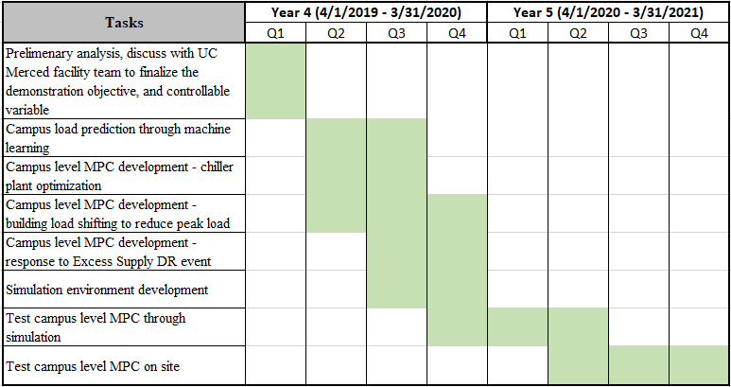

**Other previous thoughts not included in the manuscript**

* + Need to look at campus level power data and building level data and compare to utility tariff
  + Need to also look at the ratio of building controlled (e.g. fans) to uncontrolled load (e.g. plug and lighting)
  + Most closely includes buildings in MPC and opportunity for hierarchical/distributed MPC - objective may not only be peak demand reduction (instead, total bill minimization).

B. Utility Bill Reduction

* Shift charging of storage to off-peak, if not already done so.
  + Calculate estimated cost/energy savings for chiller operation to be more aligned with tariff
* Demonstrate dynamic real-time pricing
  + Compare retail tariff to day-ahead wholesale market pricing and/or real-time market pricing - could be difficult field test since cost increase compared to retail tariff.
* Manage net demand to utility including PV
  + Ask if PV is actually net metered with campus load, or treated as separate generator

C. Bi-Directional Demand Response

* Optimal preparation for increasing load according to PG&E signal to soak up solar power.
  + How often?
  + How much notice?
  + Electricity free during this time? Any other reward?
* Evaluate capability to reduce load for shedding or shifting at high price times

1. 5% chiller efficiency improvement means the chiller COP will be increased, for example, from 10 to 10.5